Experiment-8

Aim
To perform image dilation on an input image using the dilation function in OpenCV.

Procedure
- Import the OpenCV and NumPy libraries.
- Read the input image using cv2.imread().
- Convert the image into grayscale.
- Create a kernel using np.ones().
- Apply dilation using cv2.dilate().
- Display the original and dilated images.

Code
import cv2import numpy as np
img = cv2.imread("image.jpg")
gray = cv2.cvtColor(img, cv2.COLOR_BGR2GRAY)
kernel = np.ones((5, 5), np.uint8)
dilated = cv2.dilate(gray, kernel, iterations=1)
cv2.imshow("Original Image", gray)cv2.imshow("Dilated Image", dilated)
cv2.waitKey(0)cv2.destroyAllWindows()

Sample Input
An image named image.jpg.

Sample Output
The original grayscale image and a dilated image in which bright foreground regions become larger.
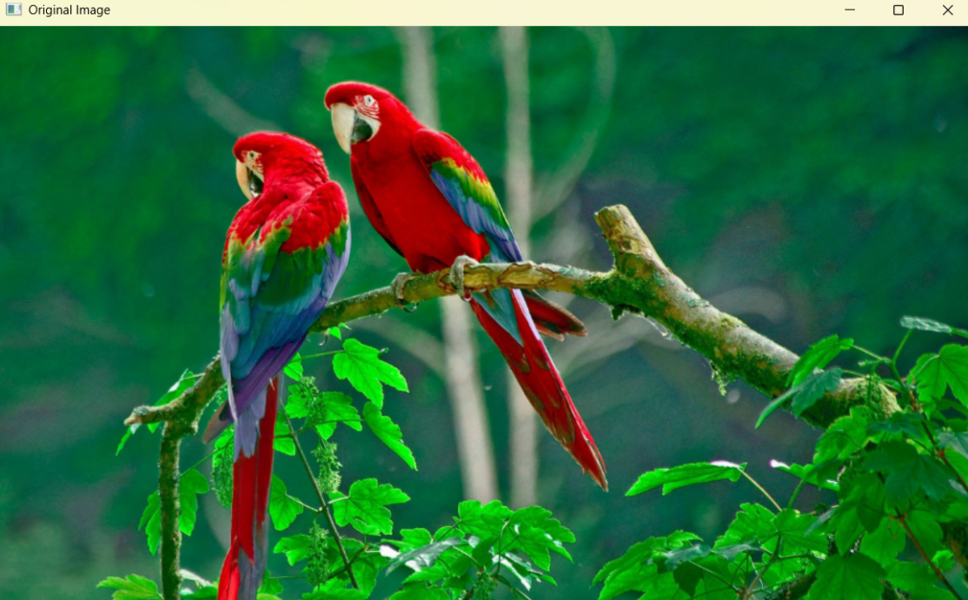
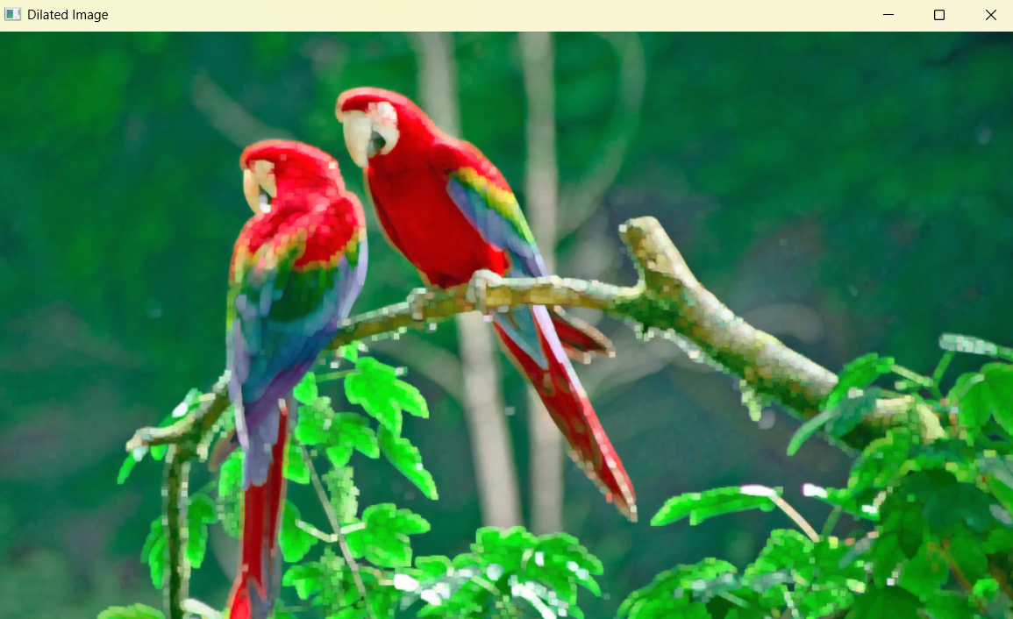

Result
Thus, image dilation was successfully performed using Python and OpenCV.

